# Michael Chillemi

# 07/12/2023

# CS 590 - Algorithms

# M8.B2: Module 8 The Greedy Method Creativity Exercises

Problem 10.5.15

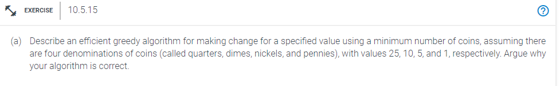

Answer:

When making a change, the greedy algorithm always chooses the largest coin denomination feasible and keeps going until the remaining value is less than the denomination before moving on to the next greatest denomination until there is nothing left.

Pseudo Code will be provided below:

Algorithm makingMinChange(remaining_amount):

Input: remaining_amount

Output: change_counter

change_counter = 0

While remaining_amount > 0

If remaining_amount >= 25

remaining_amount - 25

change_counter++

else If remaining_amount >= 10

remaining_amount - 10

change_counter++

else If remaining_amount >= 5

remaining_amount - 5

change_counter++

else If remaining_amount >= 1

remaining_amount - 1

change_counter++

return change_counter

This algorithm is accurate because of how it is built, which always aims to take the biggest chunk out of the remaining change. until the balance is zero. Therefore, this algorithm will provide the user the least amount of change necessary, whether the change is from 99 cents to 1 cent, or anything in between.